Company name swaqny

Business model:

My company runs several stores on different platforms

E-commerce by providing vouchers for more than one product and more than one international brand

We have many different Facebook pages to display the products with the purchase vouchers available to us. We request them for the customer to take the profit from the broker who provided the purchase voucher as a kind of promotion

We use Google's advertising services to advertise purchasing coupons because for every sale that takes place through the coupon, we have a profit from the broker or service provider

And examples of Facebook sites and pages that we own

https://apps.apple.com/eg/app/coupons-wadi-%D9%88%D8%A7%D8%AF%D9%8A-%D8%A7%D9%84%D9%83%D9% 88%D8%A8%D9%88%D9%86%D8%A7%D8%AA/id1589966607

https://www.facebook.com/profile.php?id=100089284564118

https://www.facebook.com/profile.php?id=100088856362733

https://couponswadi.app/

They are all owned by my company.

We only advertise coupons that we own and don't run ads for anyone else.

Tool access/use:

My tool will be used by employees, ad managers, and the programming and development team within my company to view and generate reports on ad performance.

Each employee of mine will have certain powers that benefit his position in the company and according to his use of the tools

We will have both a reporting dashboard and the ability to generate PDF reports for download.

Tool Design:

For the reporting side of our tool, we will be pulling metrics from our API into our database. The user interface of our tool will be pulled from this database to display reports. Users will have the option to view different levels of ad performance over different time periods.

My internal SQL database will sync to the AdWords API when searching for the period

To update ads based on inventory

Also,

the ads will be suspended temporarily. It is discovered that the return from the total purchase coupon is more than what was paid for in the ads, and this case is considered a loss for me.

We collect data from the broker for purchase vouchers and advertising data from Google and compare them to each other to know the profit and loss.

Calling API services:

● Pause/enable ads at the ad level via AdGroupAd

● AccountPerformanceReport Pulls reports at the account level

Examples of our company's API tools:

Note that Expenses is the total paid campaign from Google Ads

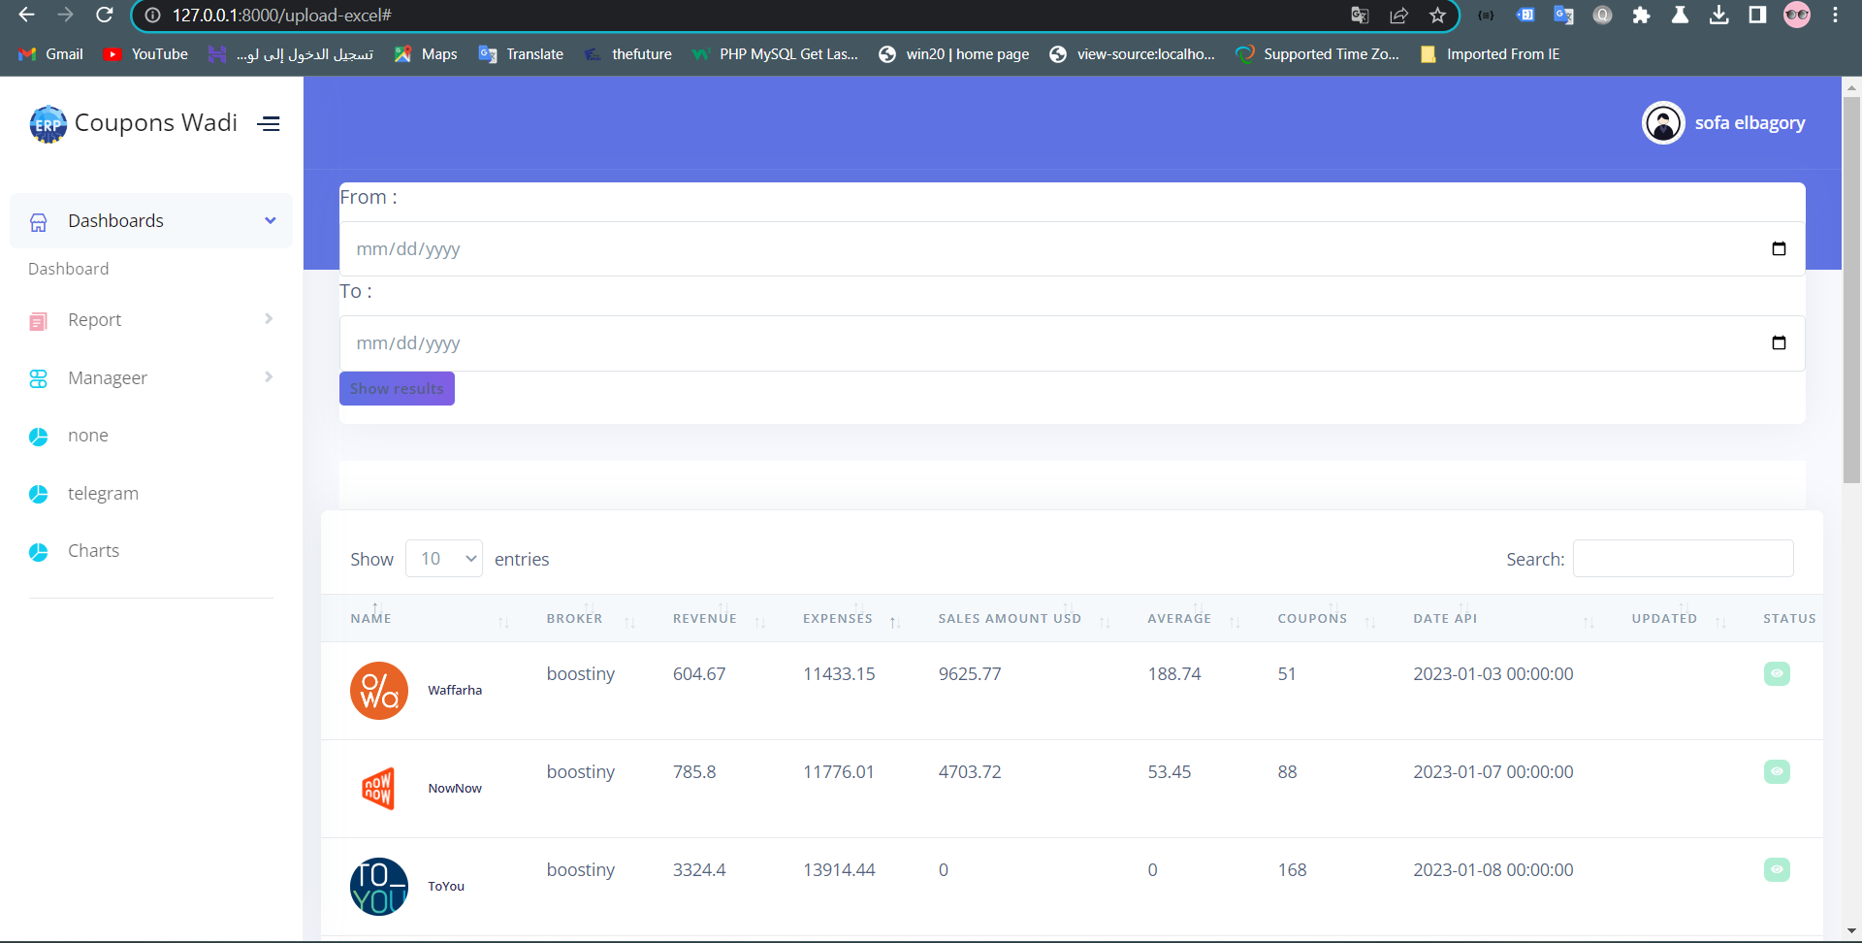

The data we collect ads and then the comparison is done

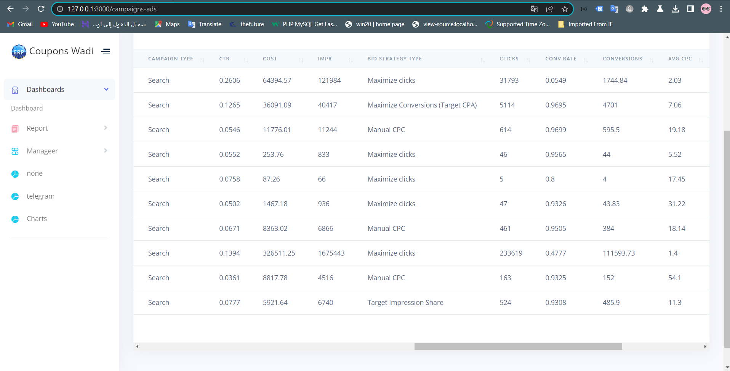

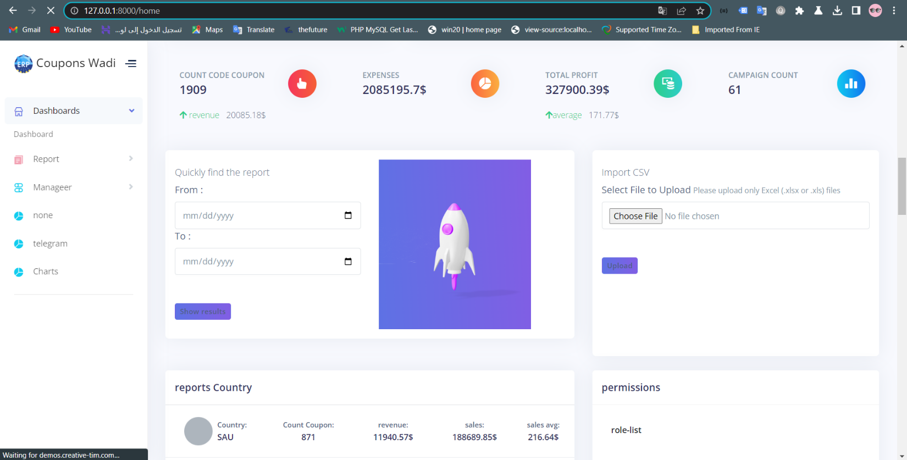dddddd

The tools are still under development from my software team

Thank you .